**Forest School Project 2022/2023 Application Form**

Thank you for your interest in our Forest School project.

Please read our ‘What is Forest School’ information sheet before applying for the project. Still interested? Great! Please complete this application form for your chance to receive a funded Forest School programme at your setting. Please return your application forms to [bbeggs@lancswt.org.uk](mailto:bbeggs@lancswt.org.uk) Once we have received your application, our Forest School Project Officer will be in touch to arrange a site visit to discuss the project. Unfortunately, not all applications will be successful. The Deadline for applications is: **Friday 11th November 2022.**

**Please note**: Our project funders, the players of the People’s Postcode Lottery, love to see pictures, videos, social media posts and articles about our Forest Schools. This is an essential aspect of our project, therefore, any school working with us must allow us to photograph, film, interview children (with parental permission) to be used by The Wildlife Trusts and The People’s Postcode Lottery for promotional purposes.

**School Details**

School Name:

Address:

Postcode:

Telephone No:

Contact Name:

Contact Email:

What is your school’s experience of Forest School or outdoor learning (if any)?

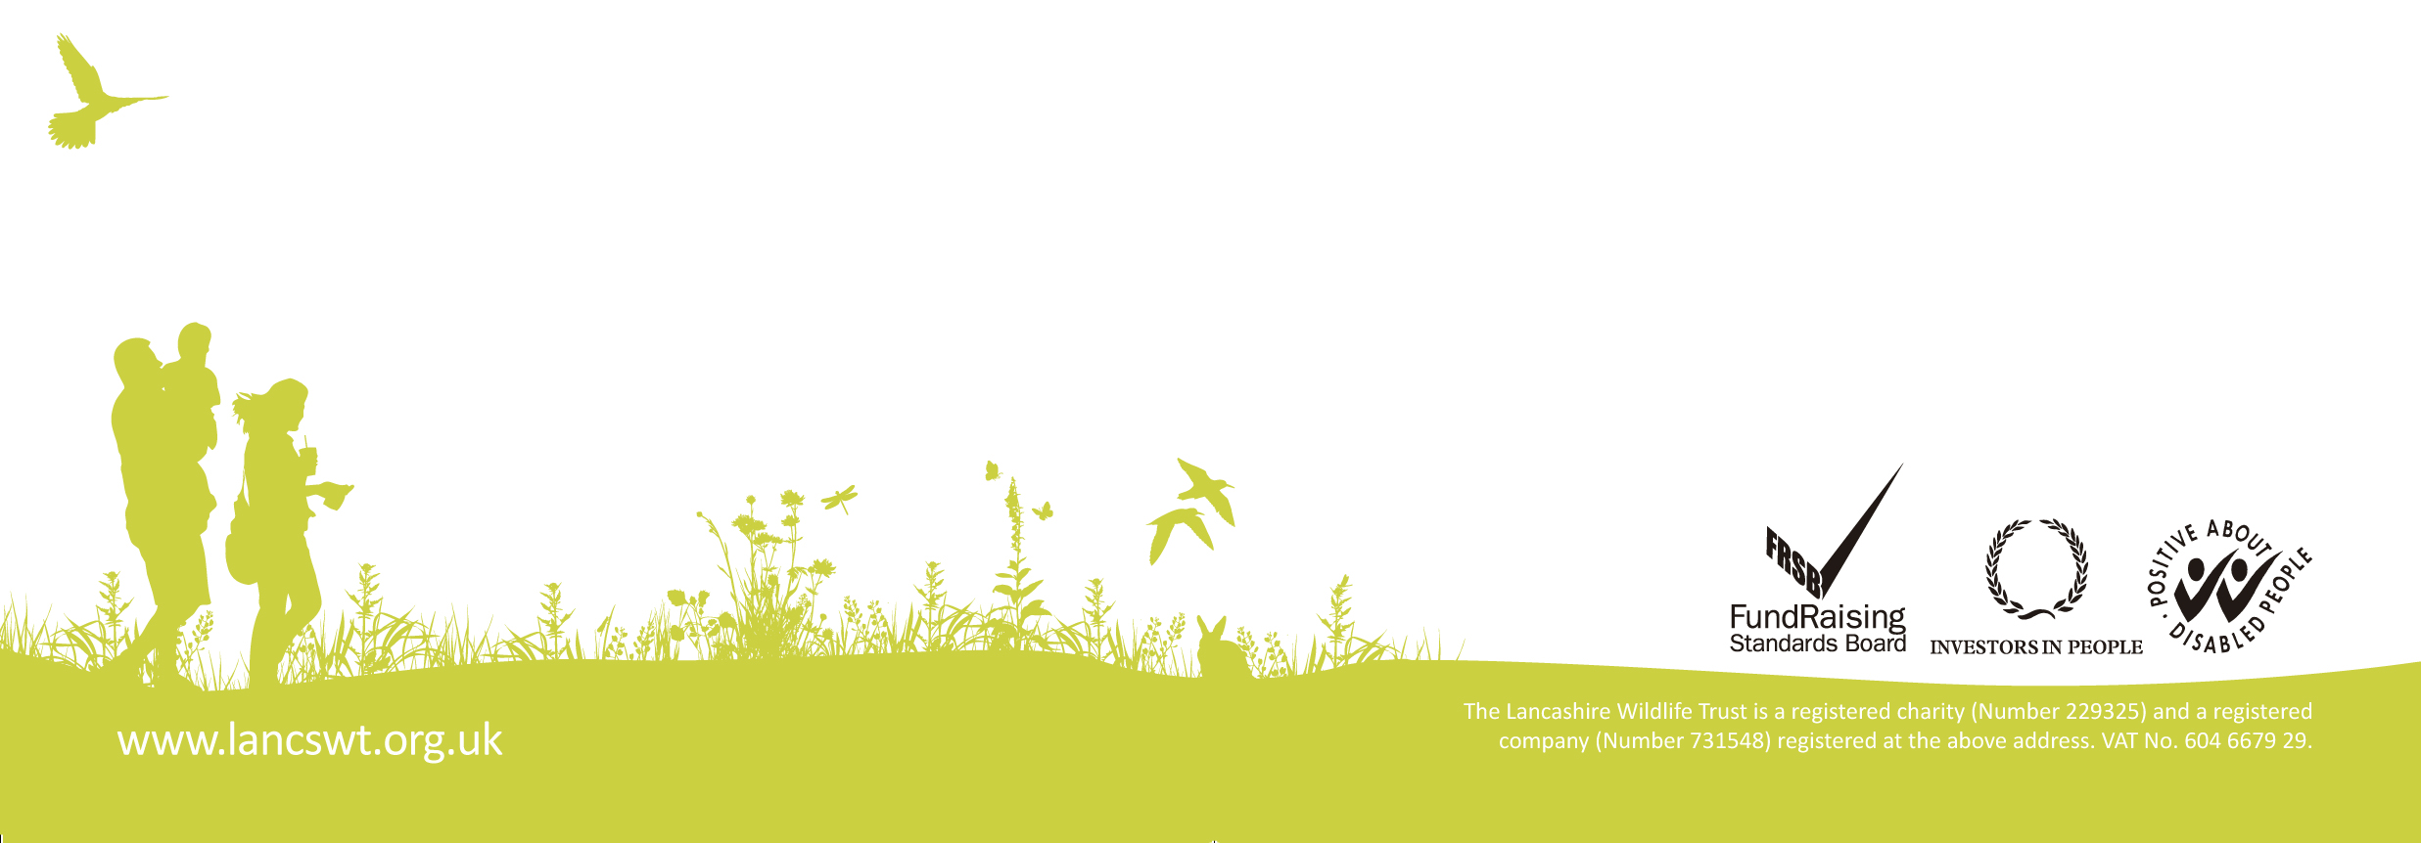

Please give a description of your school grounds or suitable greenspace you can use. Please include photographs/videos

Why do you think your school should be chosen for our Forest School project?

We will be running termly Forest School programmes with our settings, do you have a preference for the 2022/23 Spring, Summer or 2023/24 Autumn Term?

