Great Manchester Wetlands NIA Partnership
BRIEFING NOTE

Who are we?
We are a partnership of local authorities, statutory organisations, businesses, academic institutions, environmental charities and community groups who have been working together since 2011 to deliver improvements to nature and wildlife for the benefit of local communities. Great Manchester Wetlands is a locally determined Nature Improvement Area (NIA) (designated in 2013 by the Local Nature Partnership). A full list of organisations involved in the Partnership can be found at the end of this briefing note.

Where do we operate?
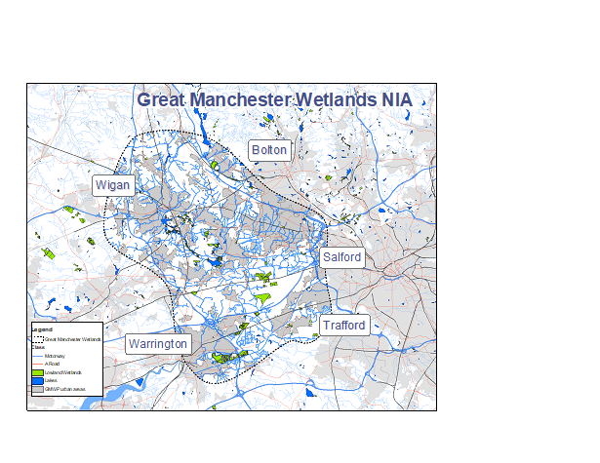
The Great Manchester Wetlands Partnership represents a landscape-scale community and natural heritage project encompassing some 48,000 ha. We focus on the wetlands within and around Wigan (the Flashes), the mosslands in and around Salford and Warrington (the Mosslands) and the Mersey corridor stretching from Rixton to Warrington, including the Woolston Eyes SSSI (the Mersey Wetlands Corridor). The area extends south-eastwards beyond the Manchester Ship Canal encompassing part of Trafford, and northwards to include a substantial corridor which is the watershed area between the Mersey and the River Douglas catchments. Whilst the area includes many valuable wildlife sites, the surrounding communities are often in areas of high social deprivation.

What are we trying to achieve?
Our vision is that:
By 2025 Great Manchester Wetlands will be a thriving, resilient and inspirational landscape that delivers real benefits to local communities and the local economy
Our detailed objectives are:
1: To mitigate the impact of environmental pressures by improving species mobility between Lancashire, Cheshire and Greater Manchester.
2: To make a lasting improvement to four of Britain’s rarest habitats by restoring key designated sites (SAC, SSSI, LNR) and priority BAP habitats.
3: To improve regional and local connectivity for critical species by creating stepping stones and corridors between habitats and populations.
4: To optimise the ecosystem services provided by all habitats particularly the carbon storage function of lowland raised bog.
5: Continue to build and deliver a shared vision for nature recovery in the wider landscape with key partners, organisations and local people.

6. Enhance community health, wellbeing, learning and skills through improved access to nature and creative engagement with the landscape.

How will we do this?
The aim of the Partnership is to deliver a living landscape between the two heavily urbanised areas of Greater Manchester and Merseyside. Wildlife corridors are identified and appropriate and complementary wetland habitat created or restored. This delivers widescale and coherent ecological networks of wetland habitats that will help to buffer ecologically important sites and link up biodiversity hotspots to allow free movement of key species into, out of and between local wildlife sites.
Our vision is for the project to become an exemplar of biodiversity restoration, enhancement and the delivery of landscape-scale ecological networks. Working with landowners and land managers, the landscape will be managed as a whole unit, with sensitive and complementary land management being undertaken.

How will all this be achieved?
In the first five years following the Partnership’s creation in 2011 partners delivered some £5m of improvements at a range of sites across the NIA. In 2017 we were successful in attracting more extensive funding through a Landscape Partnership Bid to the Heritage Lottery Fund entitled “The Carbon Landscape”. This five-year £3.2m programme of improvement includes creation of wetland habitat such as reedbed and wet woodland, restoration of ex-peat extraction sites and improvement and linking of other sites. In addition, we will deliver a major programme of community engagement aimed at reconnecting the community with its valuable wetland heritage which is often little known and with poor access facilities, resulting in benefits in terms of health and skills and a sense of ownership of the landscape. The boundary of the Carbon Landscape project is shown on the attached map. It covers some 100 square kilometres.
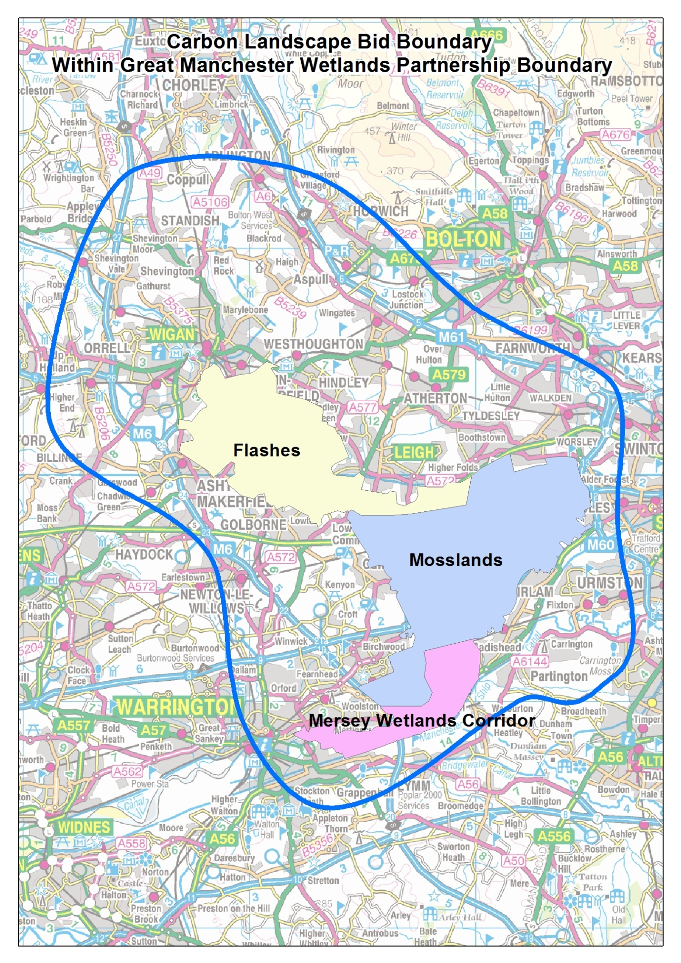

What next?
The partnership has been working to a strategic plan looking ahead to around 2025. We are now working on updating this and we are actively developing a future delivery project pipeline incorporating latest ecological data, including draft Local Nature Recovery Strategy opportunity areas and wetland ecological network models.
We are engaged in Greater Manchester’s Natural Capital programme and supporting work to introduce self-sustaining funding and investment models to protect and grow the region’s natural capital.
We intend to work with wider partners on areas of mutual interest such as peatland restoration for long term and wide-spread benefit.
We will continue to work with wider organisations to deliver our project on Species Reintroductions, reflecting the amazing progress made by partners in restoring sites and creating suitable habitat which can once again support plants and animals which have been historically lost from the area, such as the Large Heath (Manchester Argus) butterfly.
We will inform our work through the latest techniques as informed by our academic and statutory partners.

Organisations involved in GM Wetlands:

NGOs/Charities/Community Groups

- Canal and River Trust
- Cheshire Wildlife Trust
- City of Trees
- Inspiring Healthy Lifestyles
- Lancashire Wildlife Trust (Lead Partner)
- Mersey Rivers Trust
- RSPB
- The Conservation Volunteers
- Woolston Eyes Conservation Group

Local Authorities

- Greater Manchester Ecology Unit
- Salford City Council
- Trafford Council
- Warrington Borough Council
- Wigan Council

Statutory Organisations

- Environment Agency
- Forestry Commission
- Natural England

Businesses

- Peel Land and Property Group
- United Utilities

Academic Institutions

- Edge Hill University
- University of Liverpool
- University of Manchester
- Manchester Metropolitan University
- University of Salford
Other non-partner organisations are also able to be involved directly in specific project delivery.

